19.34: for adiabatic process

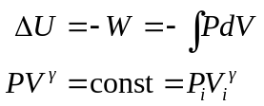

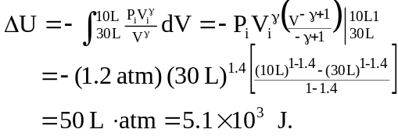

The internal energy increases because work is done on the gas 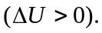
The temperature increases because the internal energy has increased.

